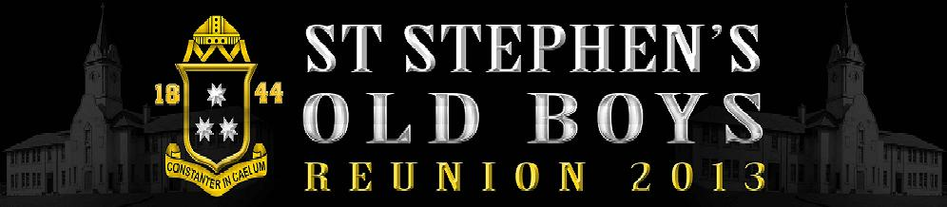Programmme!
Friday 25th:
1800hrs Registration and Early arrivals
CK Designs- Mix n Mingle Evening
Dinner- BBQ

Saturday 26th:
0530hrs Early Rise for Golfers
0545hrs Continental Breakfast
0610hrs Brougham Buses -Departs for Manukau Golf Club
Independent Traffic Control Golf Experience
0730hrs Everyone else rise
0800hrs Continental Breakfast / Cooked Breakfast
0900hrs Brougham Buses- Departs to Otara Markets
Those staying behind will have free time to enjoy
Pool, Indoor Bowls, Park, Swimming Pool and Bouncy Castles provided by RJ Building Consultants

1230hrs Buses arrive back from Markets and Golf
Those playing golf will have lunch provided at the Manukau Golf Club
Everyone Else Spit Roast Lunch provided at the MRFC

1300hrs Te Rauhitanga o Te Mano o Tipene- St Stephen’s School Old Boys Association Update and presentation
1400hrs Tutua Physiotherapy- House Touch Competition
Houses/East v West

1500hrs Toitu Design- House Tug O War Competition
House/East v West

1530hrs DFS- Tamariki Lollie Scramble
1600hrs Merit Lining Systems- Mix n Mingle (Spin Pakis)
1830hrs Tipene Reunion 2013 Formal Dinner Celebration
MC- Brent Mio
Mention Sponsors
Announce House Comps Results
Presentation Mystery Prize
MP Celebrity Roast
Auction
Open Stage- 10 Guitar Jam session Tipeneoke!

Sunday 27th:
0730hrs Breakfast
0900hrs Board Brougham Buses and Depart for Tipene
0930hrs Arrive at Tipene and brief before we go onsite
1000hrs Service / Photos
1200hrs Depart Tipene
1300hrs Lunch
1400hrs Reunion Officially Closed
1500hrs Northern Roots Tattoo After Party- Everyone Welcome to stay

